DBMS WORK

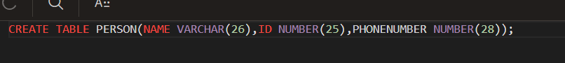



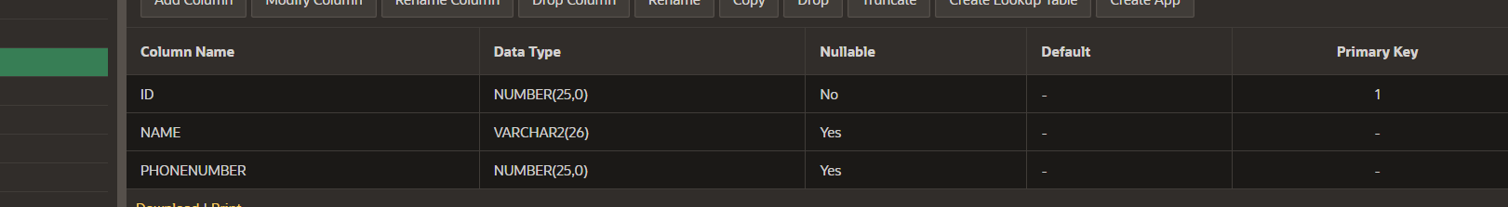





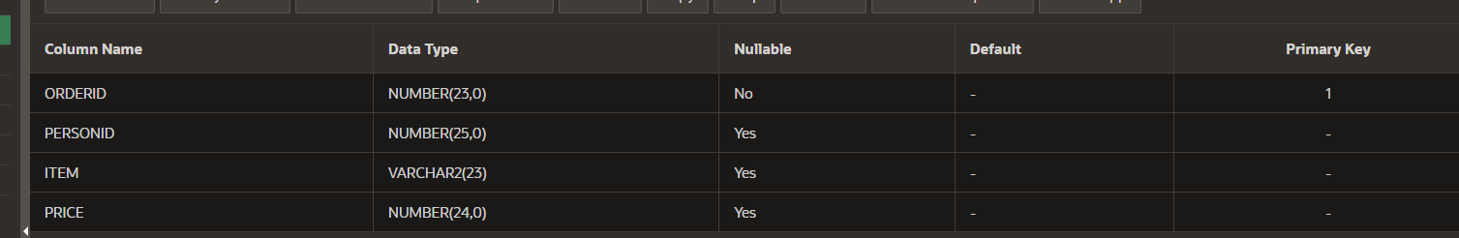

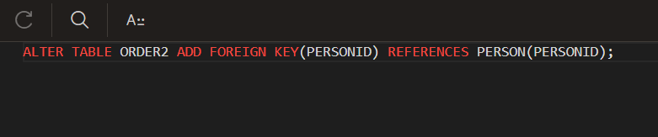

NEW ONE 31-07-24

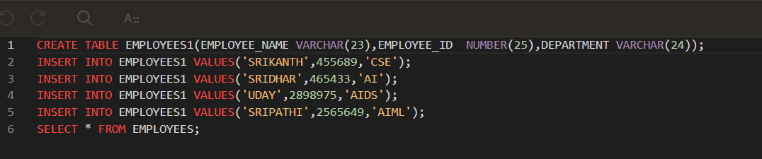

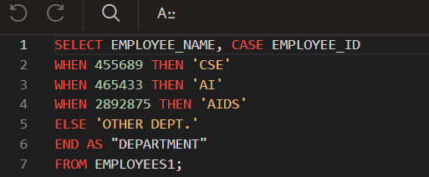

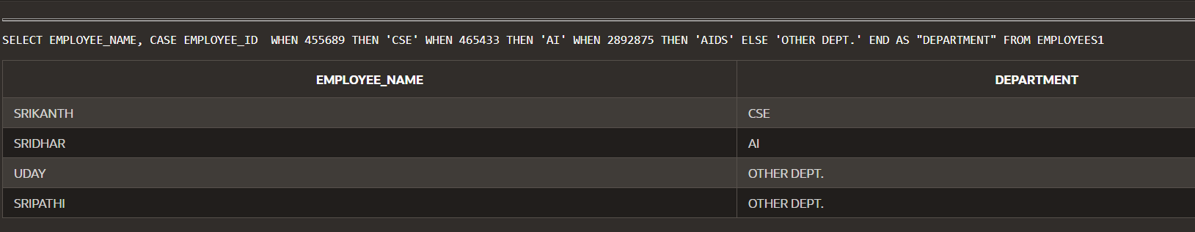

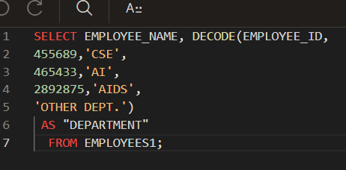

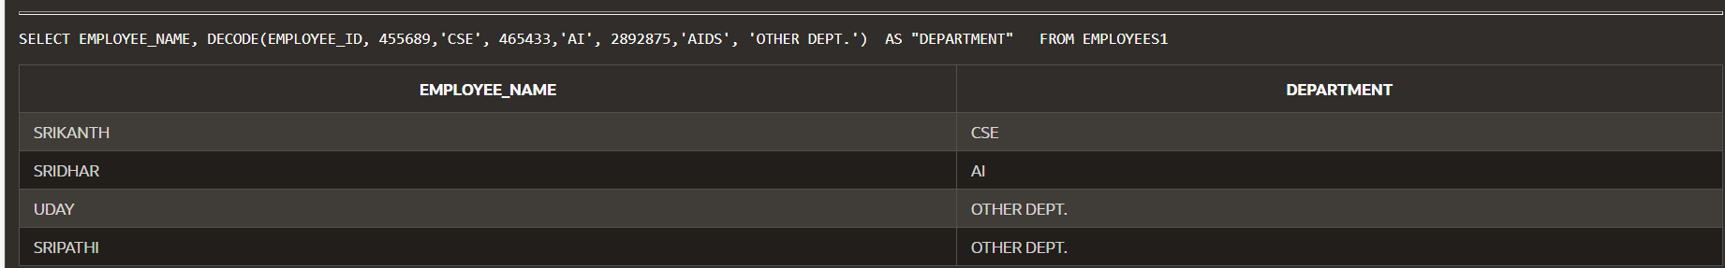

TO ADD VALUES IN GIVEN COLUMN

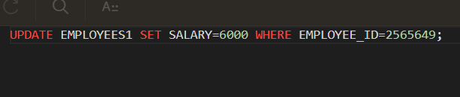



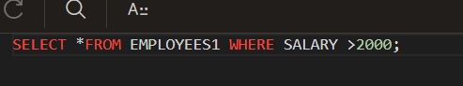

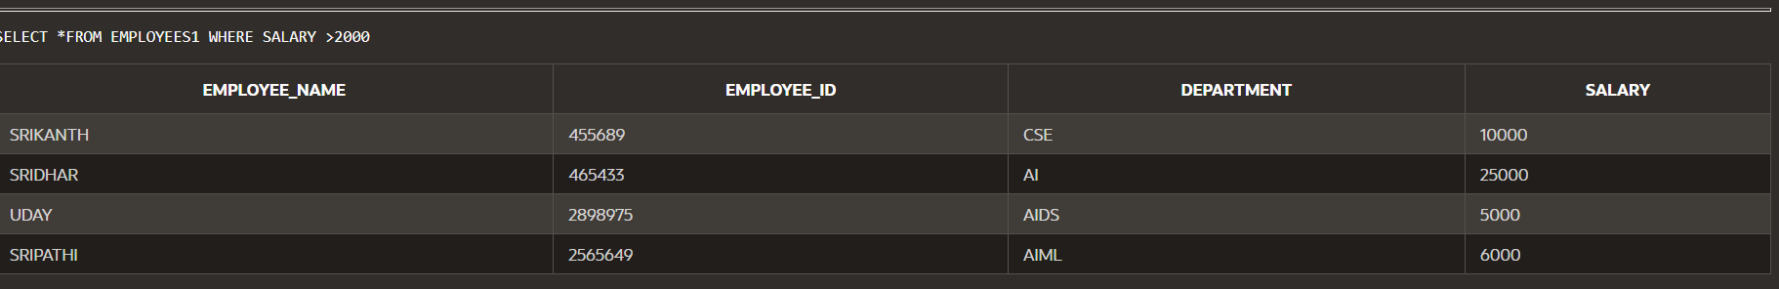

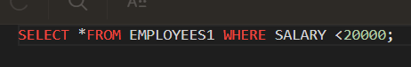

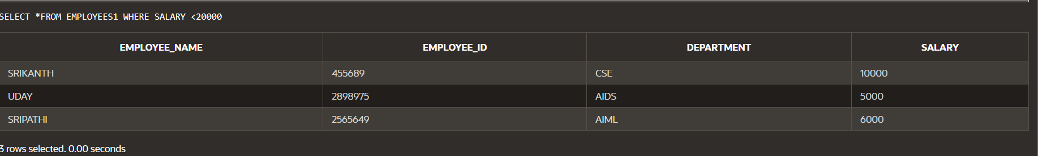

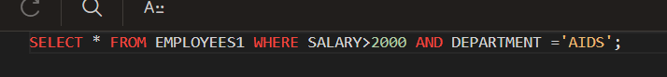

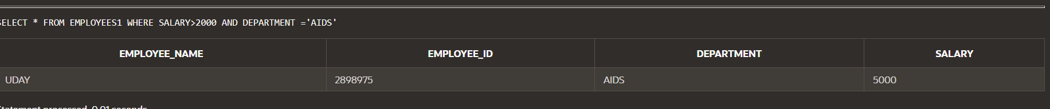



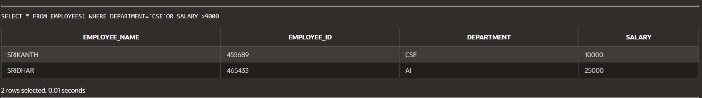

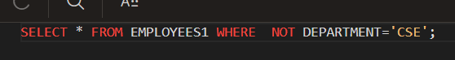

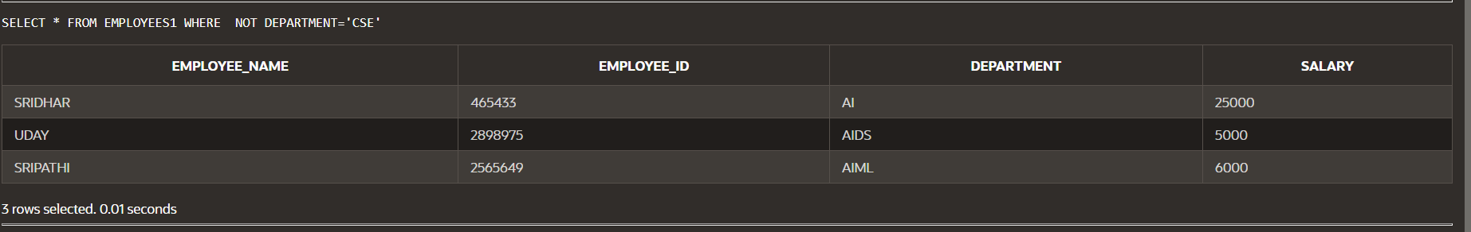

CREATE ANOTHER TABLE

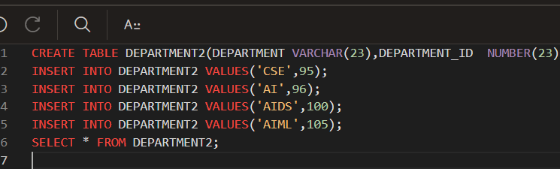



TO JOIN THE TWO TABLES

---------------------------NATURAL JOIN------------------------



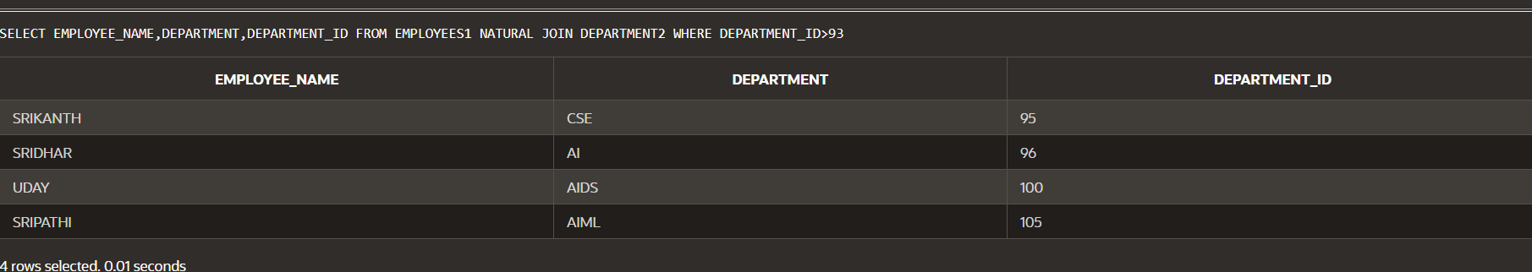

--------------------------------------CROSS JOIN------------------------------------------------------

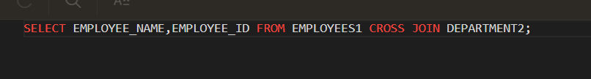

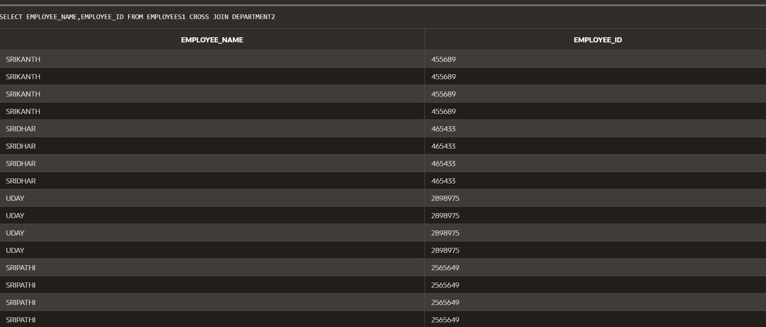

-------------------------------------JOIN USING---------------------------------------



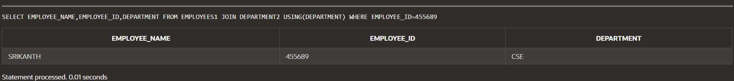

WITHOUT USING WHERE



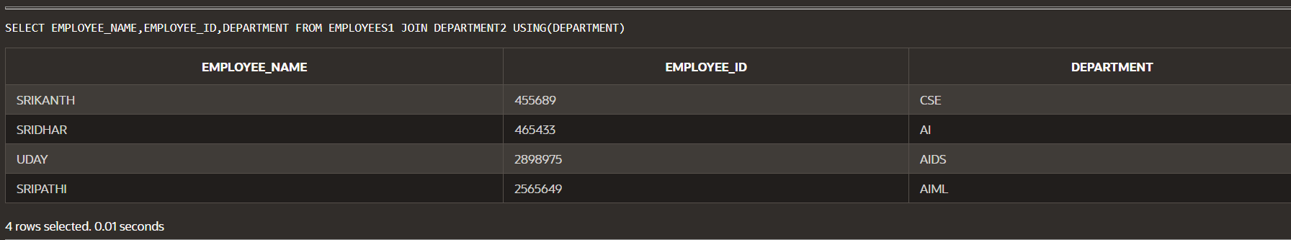

-----------------------------------ON CLAUSE----------------------------------------





-----------------ON CLAUSE WITH WHERE CLAUSE---------------------------



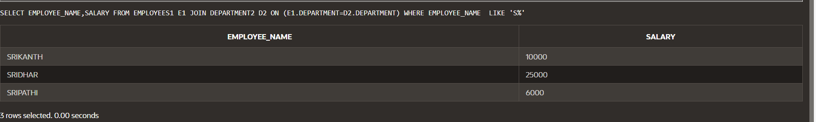

---------------------------------2.8.24------------------class------------------------LEFT JOINING-----------------



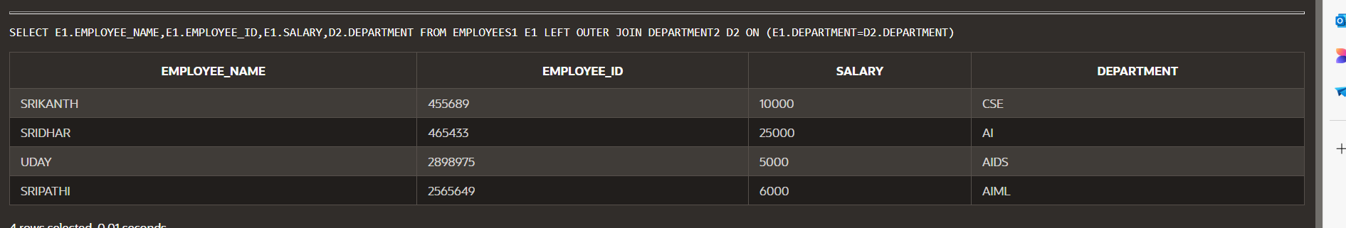

-------------RIGHT JOINING--------------------------------

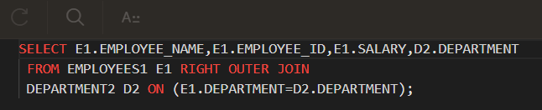

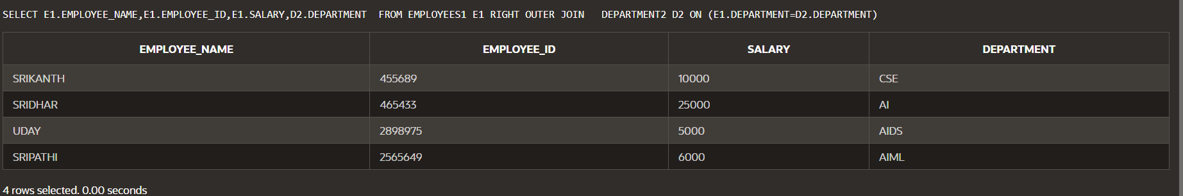

------------------------FULL OUTER JOIN-------------------------

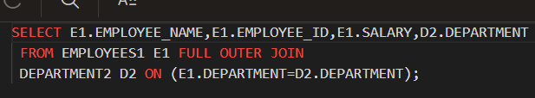

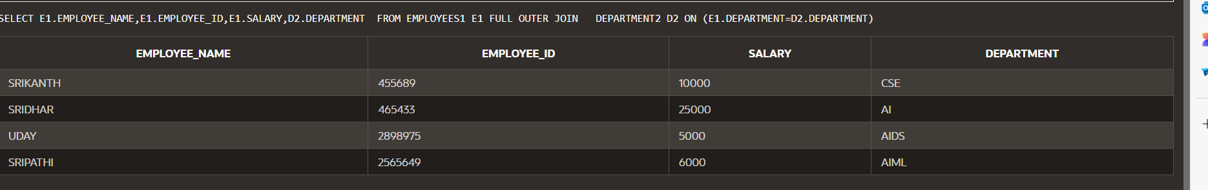

-------------------SELF JOIN----------------------

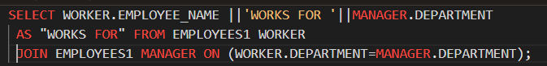



------------------------------------SAME TABLE-----------------------------

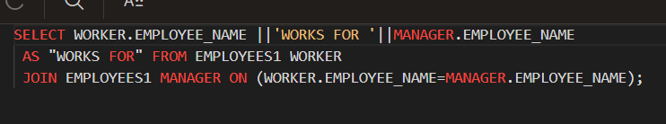

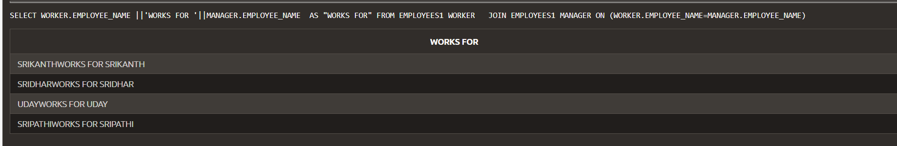

SELF JOIN EXAMPLE-----------

